IT24100571 Lab 6

1)

i)

ii)

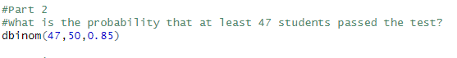

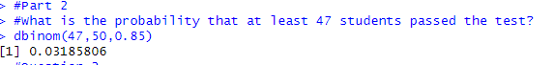

2)

i)

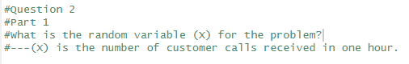

ii)



iii)



